**INTI International College Penang School of Engineering and Technology**

**3+0 Bachelor of Science (Hons) in Computer Science, in collaboration with Coventry University, UK**

**3+0 Bachelor of Science (Hons) in Computing, in collaboration with Coventry University, UK**

**Coursework cover sheet**

**Section A - To be completed by the student**

|  |  |
| --- | --- |
| Full Name:  **SATISH A/L PRAKASHAM** | |
| CU Student ID Number:  **P22014510** | |
| Semester:  **Semester 1** | |
| Session:  **August 2022** | |
| Lecturer:  **Nadhrah Abdul Hadi (nadhrah.abdulhadi@newinti.edu.my)** | |
| Module Code and Title:  **4067CEM Software Design** | |
| Assignment No. / Title:  **Continuous Assessment** | % of Module Mark:  **50** |
| Hand out Date:  **6th September 2022** | Due Date:  **Task 1: 30 September 2022, by 11.59pm.**  **Task 2: 18 November 2022, by 11.59pm**  **Task 3: 4 November 2022, by 11.59pm.**  **Task 4: 4 November 2022, by 11.59pm.**  **Task 5: 4 November 2022, by 11.59pm.** |
| Penalties: No late work will be accepted. If you are unable to submit coursework on time due to extenuating circumstances, you may be eligible for an extension. Please consult the lecturer. | |
| Declaration: I/we the undersigned confirm that I/we have read and agree to abide by the University regulations on plagiarism and cheating and Faculty coursework policies and procedures. I/we confirm that this piece of work is my/our own. I/we consent to appropriate storage of our work for plagiarism checking.  Signature(s): ________________________ | |

**Section B - To be completed by the module leader**

|  |  |  |
| --- | --- | --- |
| Intended learning outcomes assessed by this work:  1. Understand and apply appropriate concepts, tools and techniques to each stage of the software development  2. Understand and apply design patterns to software components in developing new software  3. Demonstrate an understanding of project planning and working to agreed deadlines, along with professional, interpersonal skills and effective communication required for software production  5. Demonstrate an awareness of, and ability to apply, social, professional, legal and ethical standards as documented in relevant laws and professional codes of conduct such as that of the Malaysian National Computer Confederation. | | |
| Marking scheme | Max | Mark |
| 1. User Story Mapping 2. Setting up a GitHub Repository 3. Creating a Class diagram and design pattern selection 4. Creating a Prototype User Interface and Usability Testing 5. Discuss the ethical issue related to the software | 20  10  30  20  20 |  |
| Total | 100 |  |

TASK 1: USER STORY MAPPING

VISION

What is the purpose of this system?

From this survey I have can conclude that, a buddy system application in INTI Penang can drastically improve the the environment of the campus. Almost 90% of my respondent believes that such application can improve the environment of the campus. Also, such application can help students to communicate better with one and another and improve their social interaction. So the problem will be, some students having difficulties to make friends in the campus that can help them to have a pleasant college experience. As a solving for this problem, a college buddy system is designed to aid students to make friends and to improve their social interactions. Such system in INTI Penang can improve a student’s self esteem and will be a great platform for students to engage with one another.

Who is the user of this application?

The user of this applications is the students of INTI Penang. Since the application would be used to find a new friend in campus and to improve the social interaction of the person. This is my survey google form questions

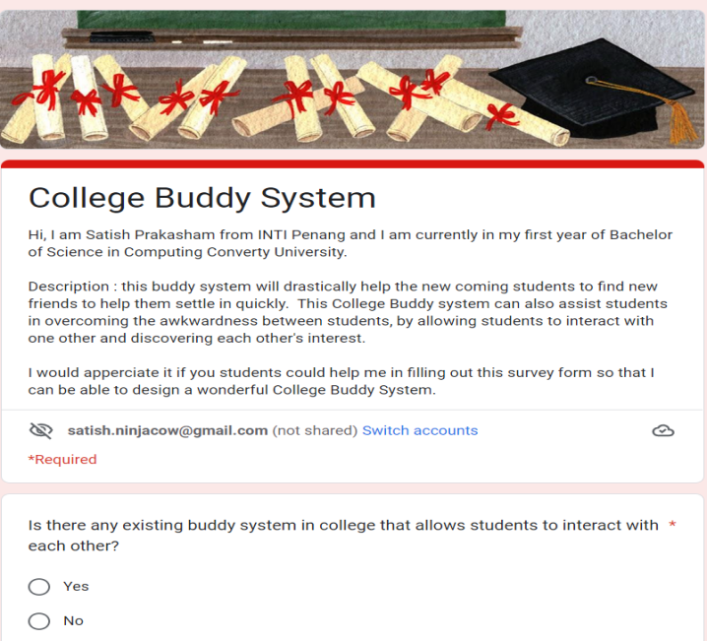

**Figure 1: College Buddy System Survey Form**

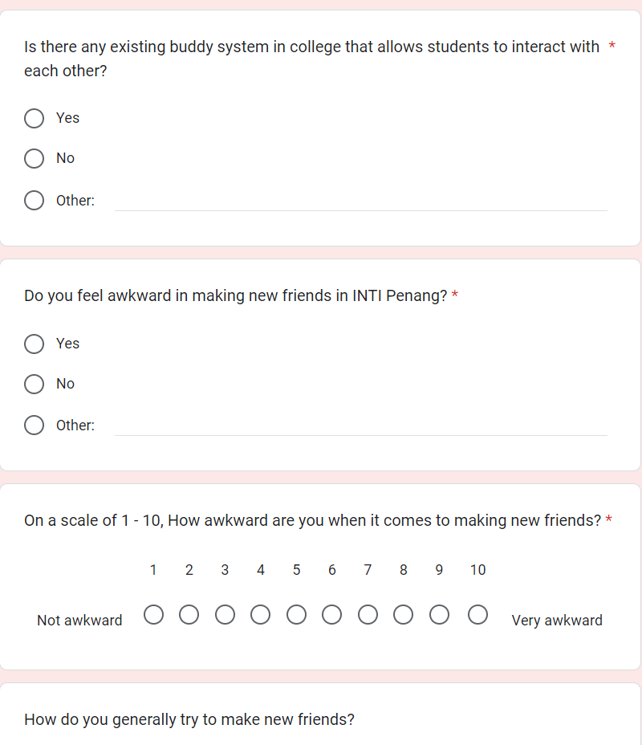

**Figure 2 College Buddy System Survey Form**

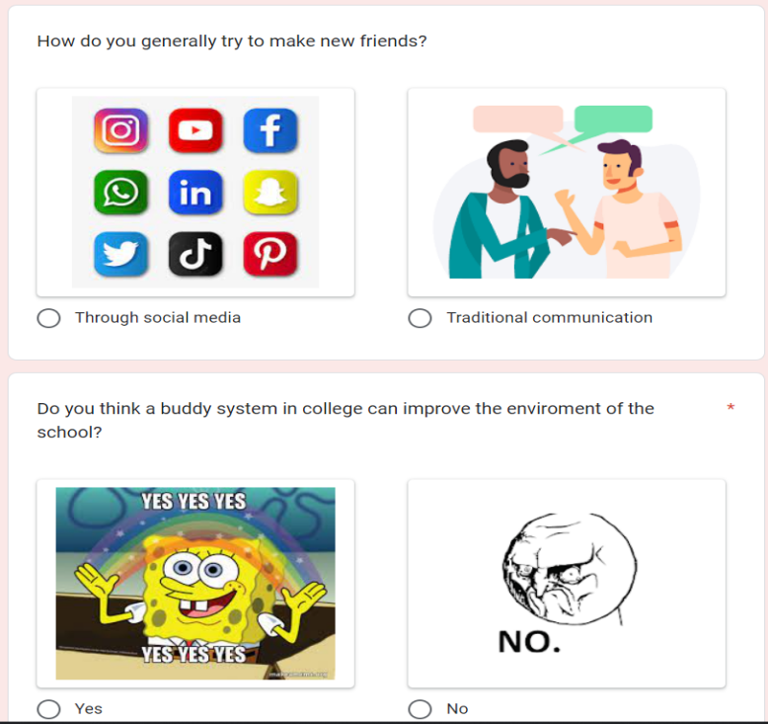

**Figure 3 College Buddy System Survey Form**

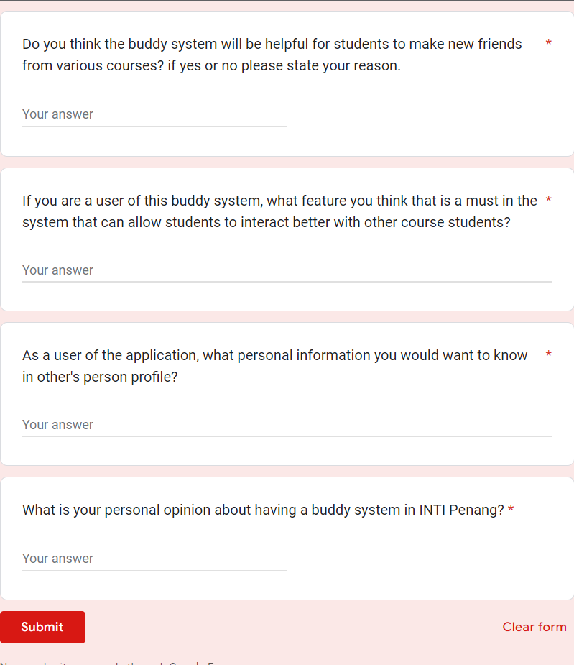

**Figure 4 College Buddy System Survey Form**

***QUESTION 1***

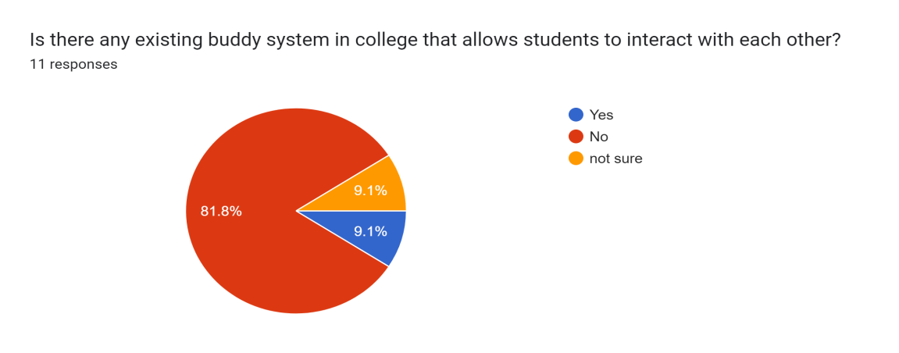

**Figure 1 : College Buddy System Survey Responses**

From this survey, I can conclude that there is no buddy system application that is currently available in INTI Penang. Since 81% of the respondent have stated NO.

***QUESTION 2***

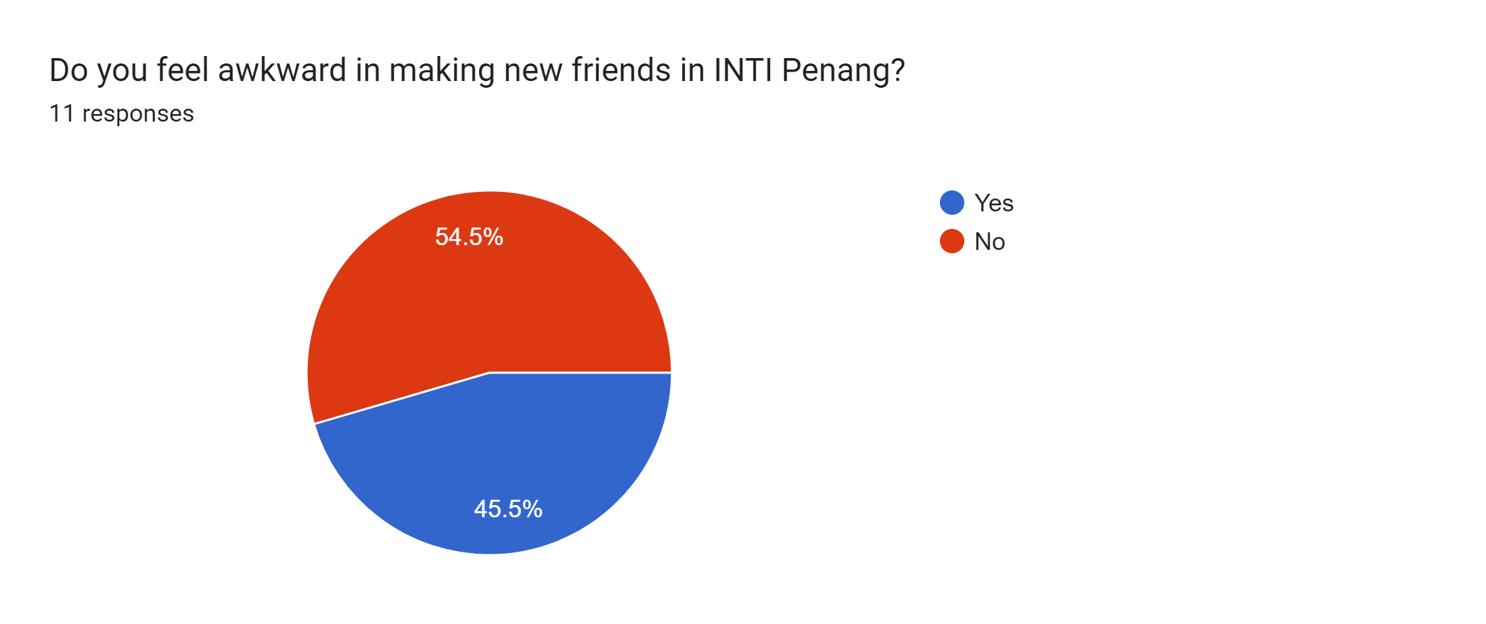

**Figure 2 : College Buddy System Survey Responses**

From the pie chart in figure 2, it can be stated that almost half of my respondents feel awkward when it comes to making new friends in INTI Penang.

***QUESTION 3***

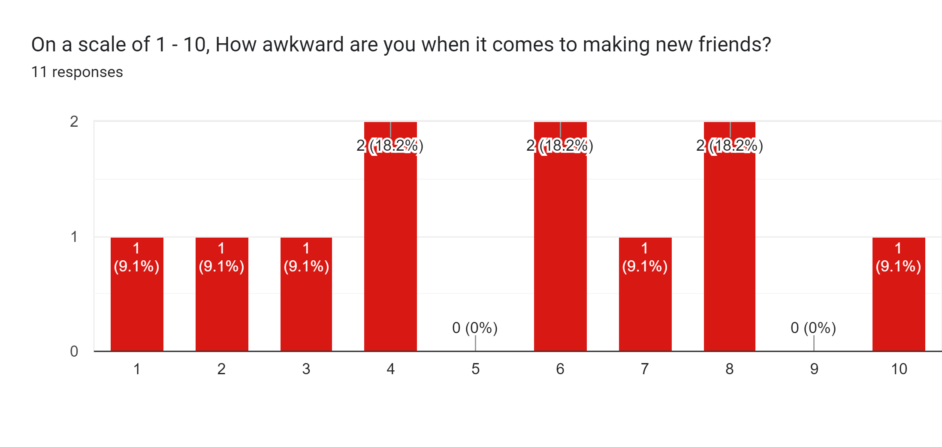

**Figure 3 : College Buddy System Survey Responses**

The graph above shows how awkward students feel when it comes to making new friends. In a scale of 1-10, only 1 respondent have chosen the maximum level of awkwardness . Where on the other hand, also only 1 respondent have chosen the lowest level of awkwardness. Where as, there wasn’t any respondent chose the scale 5 of awkwardness.

***QUESTION 4***

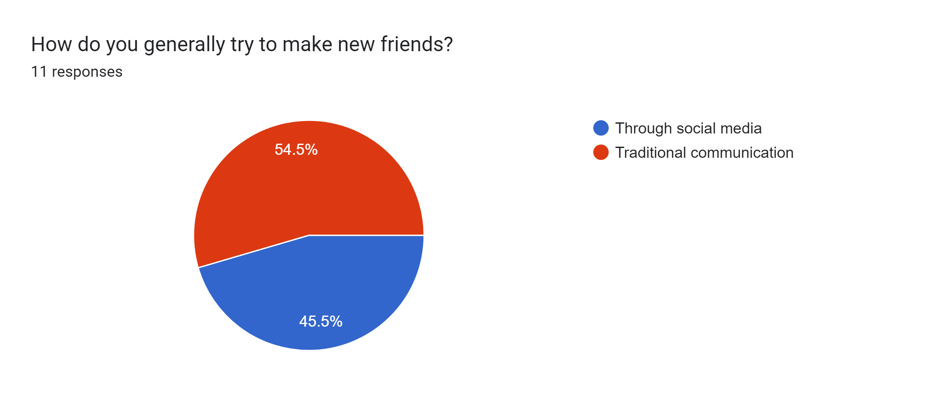

**Figure 4 :College Buddy System Survey Responses**

Figure 4 shows that 54.5% of my respondent make new friends through social media and the remaining 45.5% make new friends through traditional communication.

***QUESTION 5***

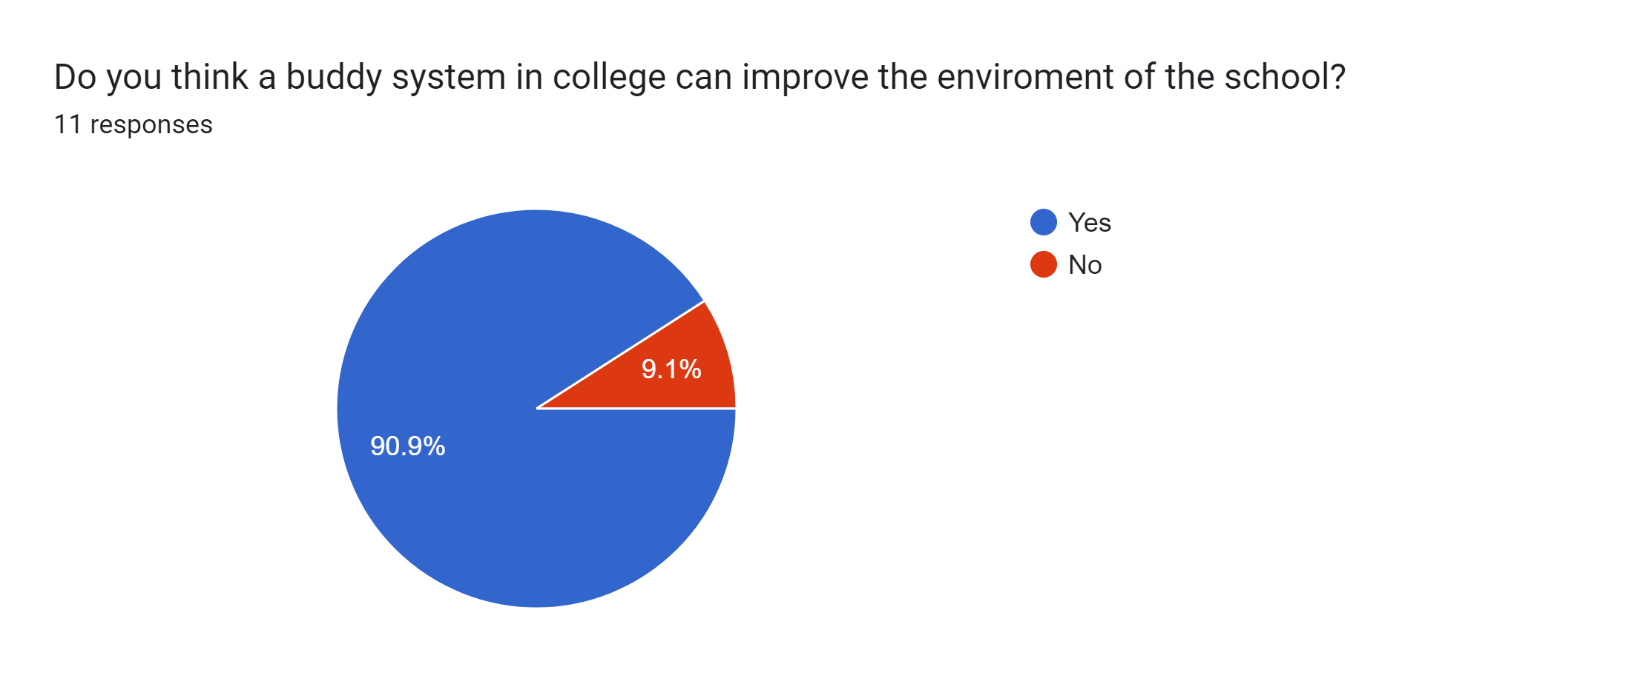

**Figure 5: College Buddy System Survey Responses**

Based on figure 5, I can conclude that 90% of my respondents believes that a buddy system application in college can improve the school enviroment.

***QUESTION 6***

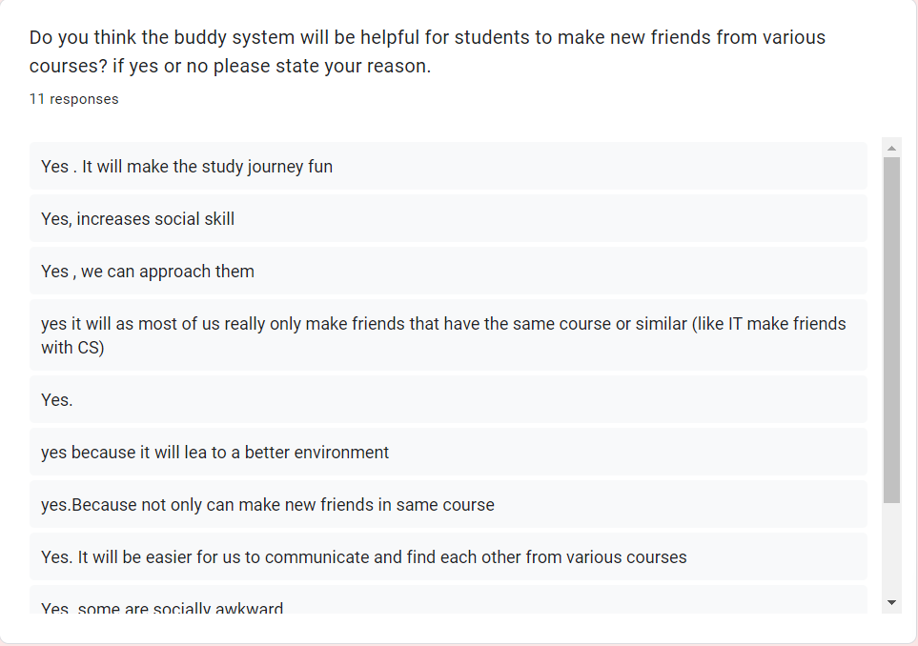

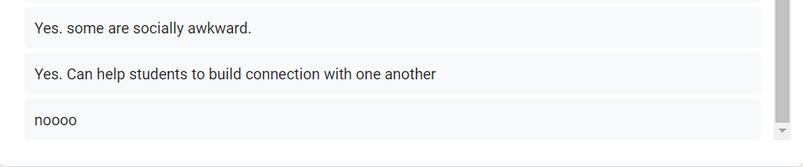

**Figure 6: College Buddy System Survey Responses**

Based on the responses above, It shows that a buddy system in college will be very helpful to make new friends based on the reason stated by the respondents

***QUESTION 7***

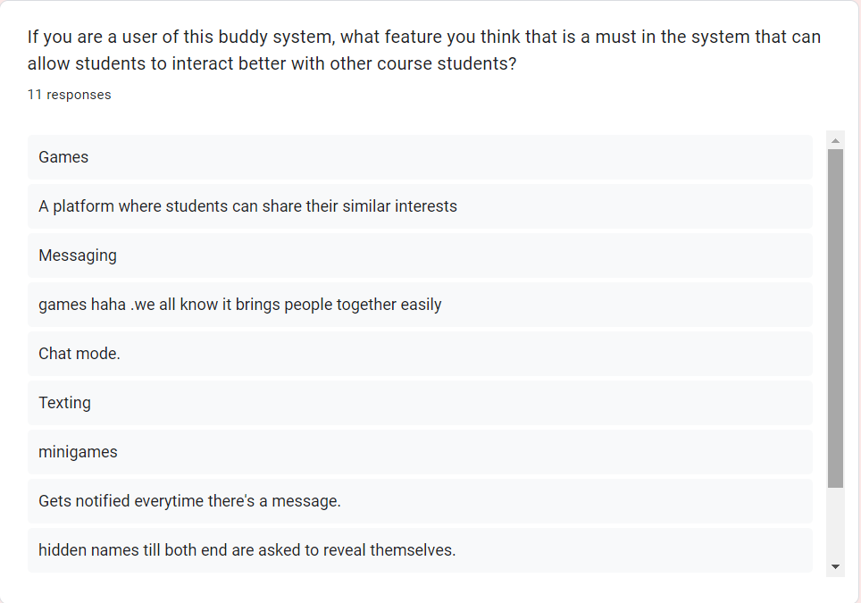

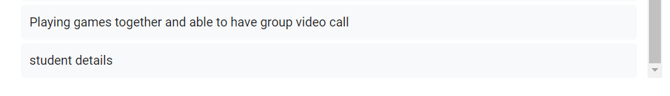

**Figure 7: College Buddy System Survey Responses**

Figure 7 shows that students chose to have games, group video call and chat room to be a feature in the application.

***QUESTION 8***

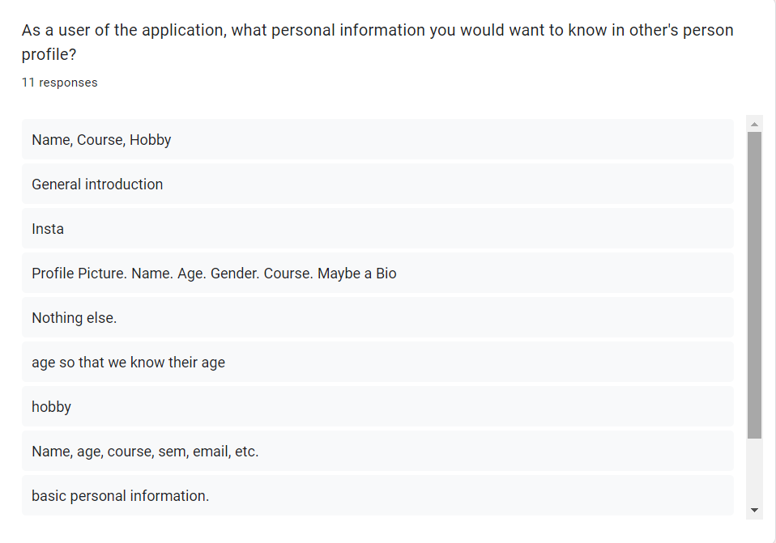

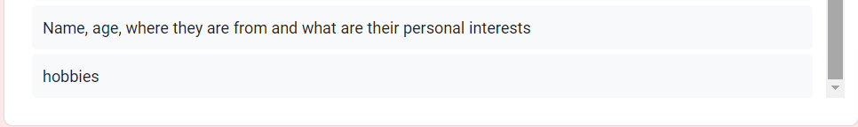

**Figure 8 : College Buddy System Survey Response**

Figure 8 shows that students would want to know more about a buddy’s basic personal informations such as name,age course and hobby.

***QUESTION 9***

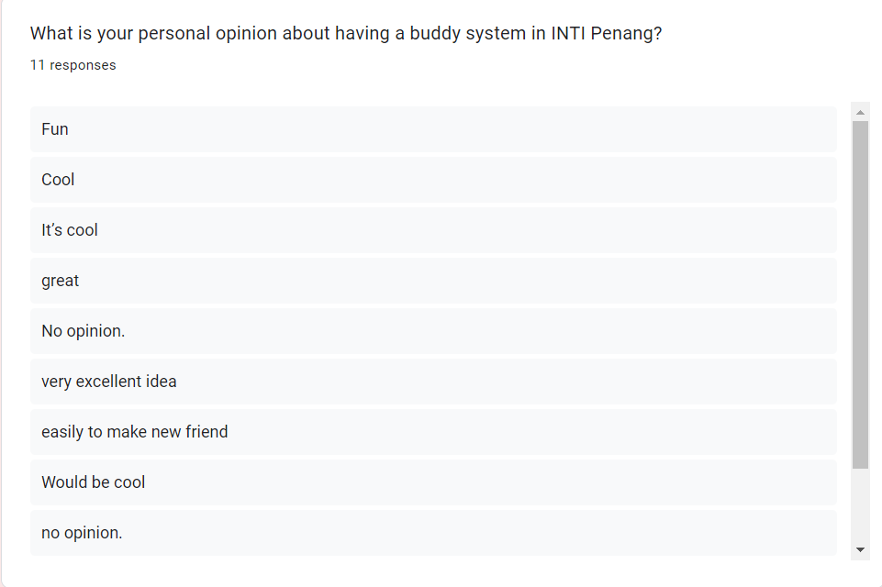

**Figure 9: College Buddy System Survey Response**

Figure 9 shows the thoughts of students on having a buddy system in INTI Penang. Most of my respondent have stated that it would be cool to have a buddy system in college.

***This is my user Story Mapping for the college buddy system***

